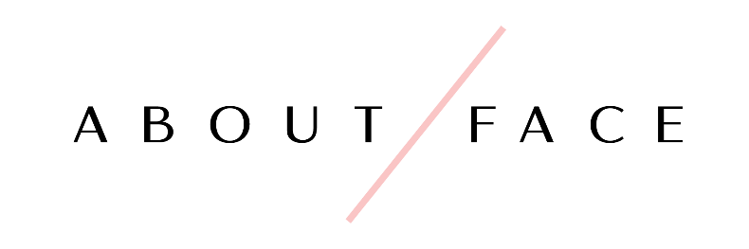

701 Metairie Road
Suite 1B 106
Metairie, LA 70056
(5040 304-1556
www.aboutfacenola.com

Bridal Makeup Contract 2019

Congratulations on your big day!

We thank you for your interest with our company and hope that we can be a part of your very special day. Below, please find the terms and pricing for our bridal services. Have you any further questions or are ready to book after your review, please call the store at 504-304-1556 or you can send an email to lindsey.benoit@aboutfaceco.com.

We look forward to hearing from you soon!

Bookings: A $100 deposit is required to secure the date of your wedding. No dates will be guaranteed without a signed contract and deposit. All bookings for weddings are made on a first come first served basis. A 3 person minimum is required in order for us to come on location.

Payments: The bride is required to pay the remaining balance of her services two weeks (14 days) prior to the wedding day and no additions or changes can be made after this date due to scheduling of artists. The $50 deposit will be deducted from the final invoice. The rest of the bridal party’s final balance is due on the day of the wedding before services are performed - no exceptions. Gratuity is added in to the price for each person receiving services so that tipping will not be necessary on the wedding day.

Cancellations: If there should be a cancellation on your part for any reason, the deposit will not be refunded. The bride is responsible for paying the amount of the service for those who cancel within the 2 week period prior to the wedding. Please inform us of any cancellations in a timely manner.

Bridal Makeup Rates
Please check one of the following packages below:

_____ Makeup on Day of Wedding Only  (In Store) - $115  Includes  - Makeup application  - False Lashes  - Airbrush makeup  - Lipstick or lip gloss for touch ups  - Gratuity included  *Price only covers bride | _____ Makeup on Day of Wedding Only  (On Location) - $175  Includes  - Makeup application  - False Lashes  - Airbrush makeup  - Lipstick or lip gloss for touch ups  - Travel fee and gratuity included  *Price only covers bride
_____ Bridal Package  (In Store) - $200  Includes  - One trial run makeup application  - Makeup application on the day of the wedding  - Lashes at both appointments  - Airbrush application at both appointments  - Lipstick or lip gloss for touch ups  - Complimentary skincare consultation  - Package secures same makeup artist for trial and day of wedding makeup  - Gratuity included  *Package price only covers the bride | _____ Bridal Package  (On Location) - $285  Includes  - One trial run makeup application  - Makeup application on the day of the wedding  - Lashes at both appointments  - Airbrush application at both appointments  - Lipstick or lip gloss for touch up  - Complimentary skincare consultation  - Package secures same makeup artist for trial and day of wedding makeup  - Travel fee & gratuity included  *Package price only covers the bride

Bridal Party Pricing:
Please specify quantity of the following

Makeup for Bridesmaids, Mother of the Bride/Groom, Other:

In Store:

______ Bridal Party - $80
(Your choice of traditional/airbrush foundation, false lashes, and gratuity included)

On Location:

______ Bridal Party - $85
(Your choice of traditional/airbrush foundation, false lashes, and gratuity included)

Bridal Information

Name of Bride: ____________________________

Phone #: ___________________________

Email: _____________________________

Wedding Date: ______________________

Time party needs to be ready by: ___________________

On Location Address _____________________________________

City ________________ Zip Code_________________

Home Address _____________________________________

City ________________ Zip Code_________________

Makeup Artist Requested (optional): ____________________

I have read and understand and agree to the terms and conditions of this contract.

_____________________________ _______________________
Signature Date

Notes: ____________________________________________________________________________

____________________________________________________________________________

____________________________________________________________________________

Deposit Paid: ______________ Balance Paid: ______________

