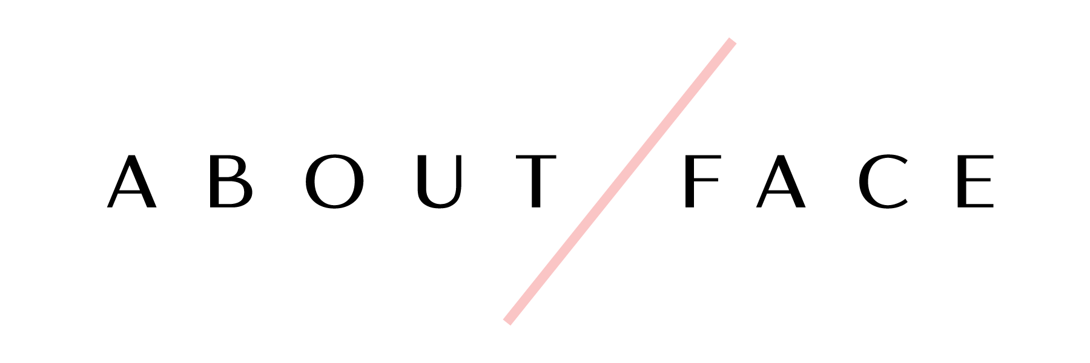
701 Metairie Road • Suite 1B 106
Metairie, LA 70005
(504) 304-1556

Bridal Makeup & Hair Contract 2020

Congratulations on your big day!
We thank you for your interest with our company and hope that we can be a part of your very special day. Below, please find the terms and pricing for our bridal services. Have you any further questions after your review please call the store at 504-304-1556 or you can send an email to lindsey.benoit@aboutfaceco.com.

We look forward to hearing from you soon!

Lindsey Benoit
Owner

Bookings: A $150 deposit is required to secure the date of your wedding for hair and makeup services. No dates will be guaranteed without a signed contract and deposit. All bookings for weddings are made on a first come first served basis. A 3 person minimum is required in order for us to come on location.

Payments: The bride is required to pay the remaining balance of her services two weeks (14 days) prior to the wedding day and no additions or changes can be made after this date due to scheduling of artists. The $150 deposit will be deducted from the final invoice. The rest of the bridal party’s final balance is due on the day of the wedding before services are performed - no exceptions.

Cancellations: If there should be a cancellation on your part for any reason, the deposit will not be refunded. The bride is responsible for paying the amount of the service for those who cancel within the 2 week period prior to the wedding. Please inform us of any cancellations in a timely manner.
Bridal Makeup & Hair Rates
Please check one of the following packages below:
_____ Makeup & Hair on Day of Wedding Only  (In Store) - $196  Includes:  - Makeup application & Bridal Hair  - False Lashes  - Airbrush application  - Lipstick or lip gloss for touch ups  - Gratuity included  *Price only covers bride | _____ Makeup & Hair on Day of Wedding Only  (On Location) - $265  Includes:  - Makeup application & Bridal Hair  - False Lashes  - Airbrush makeup  - Lipstick or lip gloss for touch ups  - Gratuity ad Travel Fee included  *Price only covers bride
______ Hair and Makeup Package  (In Store) - $358  Includes:  - One trial-run makeup application and hair trial  - Makeup application and bridal hair on the day of the wedding  - Airbrush application at both appointments  - Lashes at both appointments  - Lipstick/lip gloss for touch ups  - Package secures same makeup artist and hair stylist for both the trial and day of wedding  - Gratuity included  *Package only covers the bride | ______ Hair & Makeup Package  (On Location) - $460  Includes:  - One trial-run makeup application and hair trial  - Makeup application and bridal hair on the day of the wedding  - Airbrush application at both appointments  - Lashes at both appointments  - Lipstick/lip gloss for touch ups  - Package secures same makeup artist and hair stylist for both the trial and day of wedding  - Gratuity and travel fee included  *Package only covers the bride

Bridal Party Pricing:
Please specify quantity of the following

Bridesmaids, Mother of the Bride/Groom, Other

Makeup – All pricing includes traditional/airbrush makeup, lashes, and gratuity

In Store

______ Makeup Application - $80

On Location

______ Makeup Application - $85

Hair – All pricing includes gratuity

In Store

______ $75/per person

On Location

______ $86/per person

Bridal Information

Name of Bride: _______________________________________________________________________

Phone #: ______________________________ Email: ___________________________________

Wedding Date: ______________________ Time party needs to be ready by: ___________________

On Location Address __________________________________________________________________

City _________________________________ Zip Code_____________________________________

Home Address _______________________________________________________________________

City _________________________________ Zip Code_____________________________________

Makeup Artist Requested (optional): ______________________________________________________

I have read and understand and agree to the terms and conditions of this contract.

___________________________________________ ____________________________________
Signature Date

~~~~~~~~~~~~~~~~~~~~~~~~~~~~~~~~~~~~~~~~~~~~~~~~~~~~~~~~~~~~~~~~~~~~~~~~~~~~~~~~~~~~~

Please list all ladies who need hair and makeup services. Circle service(s) needed.
- ______________________________ makeup hair both
- ______________________________ makeup hair both
- ______________________________ makeup hair both
- ______________________________ makeup hair both
- ______________________________ makeup hair both
- ______________________________ makeup hair both
- ______________________________ makeup hair both
- ______________________________ makeup hair both
- ______________________________ makeup hair both
- ______________________________ makeup hair both
- ______________________________ makeup hair both
- ______________________________ makeup hair both

