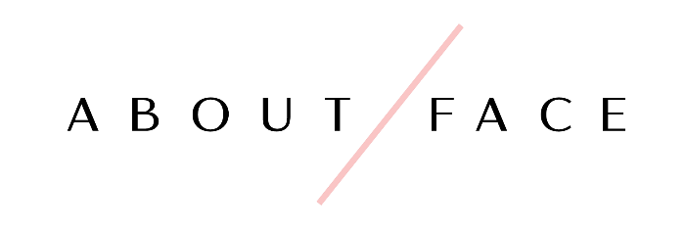

701 Metairie Road, Suite 1B 16
Metairie, LA 70005
504-304-1556

Bridal Makeup Contract

We thank you for your interest with our company and hope that we can be a part of your wedding day! Have you any further questions or are ready to book after your review of this contract, please call our store at 504-304-1556 or you can send an email directly to our owner, Lindsey Benoit, at Lindsey.benoit@aboutfaceco.com.

We look forward to hearing from you soon!

Bookings: A $100 nonrefundable deposit is required to secure the date of your wedding for makeup services. No dates will be guaranteed without both a signed copy of our contract and a deposit. All bookings for weddings are made on a first come first served basis. A 3-person minimum is required for us to come on location.

Payments: The bride and bridal party are required to pay for their services at least one week (7 days) prior to the wedding day and no additions or changes can be made after 30 days before the wedding date due to the scheduling of artists. The $100 deposit will be deducted from the bride’s final invoice. We accept cash, check, Venmo @aboutfacenola, or credit card. No money shall be collected on the day of the wedding.

Additional Fees: An additional travel fee will be added on to any on location package for the following locations: Mandeville - $25, Slidell - $25, Baton Rouge - $50, Mississippi - $75, Beyond – will be discussed at time of booking. If we must start our services before 8am due to an early ready time, a $50 fee will be required. If your wedding is on a day that we are normally closed (Sunday’s, Holidays, etc.) and we can accommodate you, an additional $75 fee will be added on. These fees may change however due to how many artists are scheduled and will be determined and discussed upon booking.

Cancellations: If there should be a cancellation on your part for any reason, the $100 deposit will not be refunded. The bride is responsible for paying the amount of the service for anyone in the bridal party who cancels 30 days prior to the wedding date. Please inform us of any cancellations in a timely manner. If there should be a change of artist prior to the wedding date on our part, we will inform you in a timely manner and have a replacement booked in their place.

Bridal Makeup Packages

The packages below only cover the bride. Please select one of the following bridal packages:

_____ Makeup on Day of Wedding Only  (In Store)  $115  Includes:  Makeup Application  False Lashes  Lipstick/Lipgloss to keep for touch ups  Gratuity |  | _____ Makeup on Day of Wedding Only  (On Location)  $175  Includes:  Makeup Application  False Lashes  Lipstick/Lipgloss to keep for touch ups  Gratuity  Travel Fee
______ Deluxe Makeup Package  (In Store)  $200  Includes:  One makeup trial prior to wedding day  Makeup application on the day of the wedding  False lashes at both appointments  Lipstick/Lip gloss to keep for touch ups  This package secures the same makeup artist and hairstylist for both the trial and day of wedding  Gratuity |  | ______ Deluxe Makeup Package  (On Location)  $285  Includes:  One makeup trial prior to wedding day  Makeup application on the day of the wedding  False lashes at both appointments  Lipstick/Lip gloss to keep for touch ups  This package secures the same makeup artist and hairstylist for both the trial and day of wedding  Gratuity  Travel Fee

Bridal Party Pricing
Please specify quantity of the following:

Makeup

______ $75 in store
Includes makeup application and false lashes.

______ $85 on location
Includes makeup application and false lashes. Gratuity included.

*We offer airbrush makeup if requested. It must be discussed prior to wedding day and will be an additional $25 per person.

Flower Girl (7 years old & under)

______ $20 Makeup
Includes light, age-appropriate makeup.

Please provide names of those receiving services:
- _______________________________________________ Paid __________
- _______________________________________________ Paid __________
- _______________________________________________ Paid __________
- _______________________________________________ Paid __________
- _______________________________________________ Paid __________
- _______________________________________________ Paid __________
- _______________________________________________ Paid __________
- _______________________________________________ Paid __________
- _______________________________________________ Paid __________
- _______________________________________________ Paid __________
- _______________________________________________ Paid __________
- _______________________________________________ Paid __________

Bridal Information

Name of Bride
____________________________

Phone #
___________________________

Email
___________________________________

Wedding Date
______________________

Time party needs to be ready by
___________________

Getting Ready Address
_____________________________________________

City ________________ Zip Code_________________

Home Address
_____________________________________________

City ________________ Zip Code_________________

Makeup Artist Requested (optional)

____________________

I have read and understand and agree to the terms and conditions of this contract.

_____________________________ _______________________
Signature Date

